

SenseTronic Co2 Sensor

Business Plan

Date: Sunday 27th October, 2013

Brian Murphy – x12533897 - Marketing
Ciaran Browne - Finance
Ben Callaghan – x12112241 - Management
Sam Gormley – x12467312 – Operations Management

Table of Contents

Executive Summary 4
Introduction 6
Overview 6
Marketing 7
The Market 7
Overview 7
Market Trend 7
Size and potential 8
Competition 8
Customers 10
S.W.O.T. Analysis 10
Strengths 10
Weaknesses 12
Opportunities 12
Threats 13
Market Strategy 14
Company Objectives 14
Product 14
Price 15
Place 15
Promotion 16
Costing’s/Finance 17
Assumptions to the Financial Projections. 17
Funding: 18
Term Loan 18
Investor income and Share 18
Capital 18
Use of Funds: 19
Source of Funds: 19
Credit Terms 19
Inflation 19
Organization/Management 20
Staff Requirement. 22
Operations Management 22
Quality and quality control 23
Post sale service/Customer Care 23
Live tech support 23
Returns 24
Suppliers 24
Logistics 24
Appendices 27
Appendix A 28
Appendix B 29
Appendix C 30
Tax Clearance Certificate 30
Appendix D 31
Promoters’ C.V’s. 31
Appendix E 45
Appendix F 45
References 47

Executive Summary

Company name: Sensetronic Ltd.
Address: Citywest Business Campus
Lake Drive
Dublin 24

Telephone: 01- 4510188
Fax: 01- 4526595

Co. Registration No.: 1105645XX

V.A.T. No.: IE 354621222 Accountants: Peter O Toole (ACCA),
NC Accounting,
Blackrock,
Co. Dublin.

Bank: Allied Irish Bank,
Village Green,
Tallaght,
Dublin 24.

Senstronic Ltd. is a company recently formed by the four promoters – B. Callaghan, B. Murphy, S. Gormley, C. Browne - to provide a service to an identified market for the manufacture, supply and installation of Co2/Temperature sensors designed for small buildings such as Households, offices, classrooms and crèches.

The company’s objectives for the future are:
SenseTronic Ltd. hope to sell 4800 units in our first year of business resulting in a profitability of 10% in year 1.
In our first year in the Co2 sensors market we hope to achieve 15% market share.
In year 2 we hope to gain 25% market share, selling 5500 units receiving a profitability rate of 16.5%.

Our long term objective is to buy our own premises in the Dublin area.
To secure ISO 9000 accreditation in the short term.
Medium Term - to buy its own premises in the Dublin area.

This Business Plan is produced with a view to securing the necessary investment from:
Term Loan € 150,000
Investment € 60,000
Overdraft Facility € 25,000
County Enterprise Board € 20,000

Introduction

Overview

Senstronic Ltd. is a recently formed company that will manufacture, supply and install Co2/Temperature sensors to the household and small business market.

The promoters have identified a niche within the household and small business market for the supply of safety sensors that will detect the presence of high amounts of Co2, CO, natural gas and varying temperatures within a confined area.

Currently there are no locally produced safety sensors in Ireland that include the features of the Sensetronic product.This gives Sensetronic Ltd. the opportunity to firstly skim the market with market saturation expected by 2016. Sensetronic hope to become a household name within the safety sensor market.

In view of the foregoing Sensetronic Ltd. have put together a competent team and business plan in response to the niche market opportunity.

The type of work services typically provided will comprise:
- Production and supply of units,
- Installation of sensors,
- Maintenance of units.

Marketing

The Market

SenseTronic is set to operate within the Co2 sensors niche market. The market for Co2 sensors in Ireland is quiet. There are not many companies producing the product that SenseTronic plan to sell.

Overview

The global market growth for Co2 products can be seen in the table below:
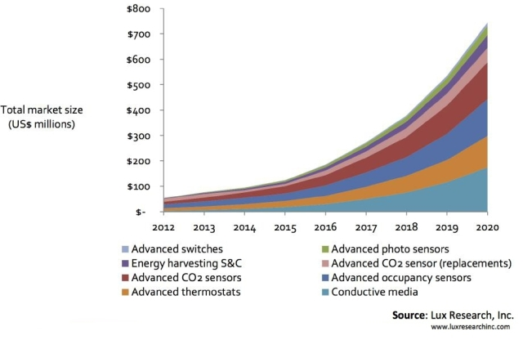

Market Trend

At the moment, the market for Co2 sensors in Ireland is small but forecasters predict that the market will increase by 10% per annum.

Size and potential

SenseTronic’s product is expected to sell because of the importance of monitoring Co2 levels, CO levels and detecting gas leakages. It could potentially be used in households to monitor room temperature. The niche market of Co2 sensors is expected to grow largely by 2016 so have the potential to grow as a business and to develop a product that is superior to that of competitors. SenseTronic’s product could develop to be an essential household item and our company a household name.

The market at the moment is quiet small but as mentioned above it is expected to rise hugely by 2016 which is estimated to be worth around €145 million globally by then. It is currently worth €10.3 million which we intend to improve on them figures.

SenseTronic’s product has the potential to completely overtake the market share in Ireland for the sales of Co2 sensors.

Competition

The niche market which SenseTronic have chosen is for the distribution of Co2 sensors to customers. The niche market is valued at €10 million in the Dublin area and there are only two 3 main rival competitors in Ireland which are listed below:
- Handy Hardware
- Boc Online
- Safe Lincs

The combined turnover of the above is approximately €1.2 million.

Our completion if we sell our product outside Ireland would be the following:
- Co2 Meter
- Futurlec
The combined turnover of the above is approximately €4.2 million.

A distinct advantage SenseTronic have over these rivals are that we have an online order system along with the offering of customers to visit the warehouse which we are located to view and test our product, another advantage is that we deliver and install the product with complete training of how to use the device.

Customers

SenseTronic’s product will be targeted to customers who would use the Co2 sensor in small buildings, such as household rooms, offices, classrooms and crèches. This is because the sensor works at best in a smaller room. The product can be used to determine if it’s too hot or cold in a room. For example, if it is too cold, the sensor will suggest that the heating be turned on. An important feature that could attract customers is that the Co2 sensor will have a built in capability to detect if there is a gas leak.

List of Target Customers:
Households, Crèches, Small buildings.

S.W.O.T. Analysis

Strengths

SenseTronic Ltd product is an improvement on existing products. The product SenseTronic are offering entails better features than competitors at a reasonable cost. The product has become a necessity in households and businesses within Ireland. The senor product is manufactured with quality materials that will endure a long lasting life. At present our company has an excellent cash flow. SenseTronic’s accountants manage the cash budget on a monthly basis. The competitors market for our product is small which means we have a good chance of gaining high market share.

SenseTronic employ and use professional staff members that have experience in the industry of sales and marketing. Each member of staff wears distinctive clothing uniforms that advertise and present the company in a professional way. The experience the staff members have will secure new customers and probably attract further customers by word of mouth.

SenseTronic is located within the well-known Citywest Business Campus which includes the Luas nearby for easy transportation nearby. The location is easily directed to customers as it is nearby to the m50 and all routes through the city centre and tallaght. The location is easily accessed as many people know where Citywest Hotel is or the Business Campus alone. The promoters will provide great advertising by developing a professional website to allow customers to avail of orders of products online that will allow for delivery and installation, also displaying information about the company and product. We also use Facebook/twitter to promote the business to a target audience. The promoters have a proven track record in their ability to increase customer awareness of new products and most importantly the effect co2 sensors can produce on households etc. by introducing safety measures that include Co2 measurements and gas detection.

The staff members are capable of meeting deadlines by meeting targets and staying within a provided budget allowance.

Weaknesses

Funding resources are low, so the business will need to possibly seek a bank loan. The cost of manufacturing and production of our product can be expensive. The product is very superior to competitors but is made to last with durable materials which will give a high retail cost. Attracting investors could be difficult as people may not understand the importance the sensor could bring to households etc. The product could start off selling at a slow pace as probably not many architectural firms will be interested. It may be hard to attract customers to the idea of our product as most advertising will be done by door-to-door salesmen; some people also ignore new technology.

Opportunities

The company’s immediate plan was to achieve targets set out in the Dublin region in Ireland for the first year of establishment. We intend to further our business across the entire country. After we are established in the marketplace our position will cater for €10.3 million in the market. The market is expected to rise to over €146 million by 2016, therefore now is a good time to make advances with our business.

After our original product is rolled out across the country, we intend on creating a second product that will be spanning across the entire country along with our original product.The second product will be for industrial purposes such as large businesses, colleges, restaurants etc. The product will be of high value as it will offer more features than our original one. It will allow for the users to detect gas, monitor Co2 levels, if it is too cold it will suggest the heating is turned on or if it is too hot the air conditioning will be automatically turned on by means of a connected Ethernet cable. There will also a feature to open windows that are electrically powered.

We expect to receive greater profit after our second product is rolled out across the country and our plan will be to enter the European marketplace.

Threats

The greatest threat to our business at the moment would be convincing cost-conscious consumers to spend on a superior product which they have never used before. The growing cost of employee benefits contributes to increased product prices. Also our competitors, they design and create similar products that could offer possibly a better functionality. The more products we roll out, the more competition will up their creativity to out sell or compete with ours.

Market Strategy

In order to achieve our objectives we have devised the following marketing plan for SenseTronic:

Company Objectives

SenseTronic hope to sell 4800 units in our first year of business resulting in a profitability of 10% in year 1.
In our first year in the Co2 sensors market we hope to achieve 15% market share.
In year 2 we hope to gain 25% market share, selling 5500 units receiving a profitability rate of 16.5%.
Our long term objective is to buy our own premises in the Dublin area.

Product

The product that will be sold by our company is a wall mounted Co2 sensor. The product will have a wireless Bluetooth monitor with heads up display that will allow users to access information about the current Co2 levels of the building. A wired thermostat will be monitor temperature levels. The product will run on AA batteries which will be a low cost to purchase. The main function of the product is to test air quality and display information regarding air quality; it will return a LED notification by using the colours red, green and blue.

Blue: the temperature is too low, a suggestion for example could be to turn on the heating and close the windows. When the co2 levels reach the desired state of good air quality, the LED produces a green LED flash. Another suggestion will be made then to turn off the heating otherwise the co2 levels will go to high.

Red: The temperature is too high, a suggestion for example could be to turn off the heating and open windows, when the co2 levels have reach the desired state of good air quality then a suggestion to close the windows will be produced. With a detection of gas, a warning sound and flashing red LED will occur.
Green: Co2 levels are good.

Price

SenseTronic’s product will enter the market of Air Quality sensors at retail value of €325.00. SenseTronic set up their business for quality low cost manufacturing and production with the use of Chinese manufacturers. The following is the full pricing of the product:

Labour: €50
Materials: €220
Total Direct costs: €270
Market Selling Price: €325

Place

First of all our company name reflects on what we’re trying to sell, the name itself is easy to remember and can be thought of a brand it its own right. We will focus on selling to household customers mainly.

Our selling will be carried out with a direct door to door approach. Our professional, experienced sales and marketing team will ensure customers are attracted to the product by ensuring they understand the advantages of having the device in a household and how it can become a house. The fact that it could be used as a device for keeping the temperature at the correct level for a baby will be a huge feature to keep the customer interested to a level that could probably push a purchase and for customers to talk about our product. We will also sell from our warehouse in Citywest, an online website and offer our product through door the door-to-door.

Our product is manufactured and produced in China. The materials are also bought from Chinese suppliers to manufacture the product. The products are then shipped to
Ireland and delivered to our warehouse in Citywest. We then distribute samples of the product to each member of the sales and marketing team to use during door-to-door advances. Products that are ordered online will be loaded onto company vans to be delivered to the customer; each delivery van driver will also have been pre-trained to have the skills to install the device.

Promotion

We will promote our business mainly by our sales team approaching possible customers in households, small buildings and crèches. Additionally we will have our very own website which you can order our product, have it delivered and installed, an official Facebook and Twitter page which we will use to invite people to like our business using Facebook and get our business trending on Twitter using the # tag. Facebook and Twitter is a free tool we can use that can business can use, we find it to be essential to our business and any business alone. We will also advertise through brochures located in shopping malls, hotels, and local councils. In addition we will also put weekly advertisement ads in local newspapers.

Costing’s/Finance

Assumptions to the Financial Projections.

Full sets of financial projections for the year of the business operation are contained in the Appendices.

Sales
The sales as projected for the first year, based on direct primary research of the potential customers, are set at:
Year 1: 5% of target market
Year 2: 10% of target market

SenseTronic believe that these projections are realistic and achievable due to the large market they have available to sell in to.

Expenses
Full schedule of expenses is contained in the appended projections. The expenses as calculated are realistic and based on current prices.

Detailed Job Costing Overview

The Unit Sales / average job costing make up for the product is as follows:
Unit Pricing per Tonne;

Labour: €50
Materials: €220

Total Direct costs: €270

Market Selling Price: €325

It is necessary to base costing on a unit cost per tonne production in order to cater for the diversity in type of product being manufactured; this unit cost is used throughout the industry.

Funding:

Term Loan

The business plans of acquiring a term loan from the bank that we will repay fully within the first year of our companies establishment. SenseTronic are confident that the sum of €150,000 will be available based on initial discussions with the County Enterprise Board. We wish to take out this loan prior to starting up our business as it will supply us with important finance to help establish our firm.

Investor income and Share

Capital

The business is relying heavily on income from potential investors throughout the trading year. SenseTronic are very confident that the business can raise a large amount of income from the buying and selling of shares.

A full schedule of projected Capital Expenditure is appended.
It is intended to fund the proposed project as follows:

Use of Funds:

Capital Expenditure € 697,000
Working Capital € 800, 000
----------
€ 1,497,000

Source of Funds:

Debtors € 124, 500
Share Capital € 747,000
Term Loan € 150, 000
-----------
€ 1,497,000

Credit Terms

The ‘industry norm’ for credit (debtors and creditors) is 60days and the projections follow this norm.

Inflation

Given the current financial climate, inflation has been ignored for the purposes of this business plan.

Organization/Management

The Organisation
Sensetronic Ltd. is a private limited company with shares owned equally by four primary promoters. A copy of the Certificate of Incorporation is appended and a copy of the Memorandum and Articles of Association will be made available to the bank in the normal course.

Management Overview
Key Staff and their activities.

The combined expertise of the primary promoters has allowed for a ‘natural’ division of responsibilities as detailed hereunder:

B. Callaghan, CEO

Management
15 Years commercial business experience
Performance appraisal skills,
People management,
KPIs team development skills
Resource allocation,
BA (Hons) Management studies,
BA (Hons) International management.

S.Gormley, Operations Manager

Operations
12 Years manufacturing experience
Production scheduling
Work assignment
Health and Safety Training,
Quality Control,
Resource allocation,
BA (Hons) International management.

C. Browne, Company Secretary

Administration and Control.
Manager in
Certified Diploma in Accounting and Finance (ACCA)
BA (Hons) Finance and Business
Dip. In Personnel Management.

B. Murphy, Managing Director

Sales, Marketing.
12 years experience in the building safety market
BSc (Hons) Sales & Marketing
Diploma in Environmental Services Engineering.
Self employed for 8 years
Full Curricula Vitae for the promoters are included in the Appendices.

Staff Requirement.

Year 1 Year 2

Directors 4 4

Electricians 2 6

Apprentice Electricians 1 4

Semi-skilled 0 2

------- ------
Total : 7 16

Operations Management

This section of the plan will deal with the operations management. Each heading in this section represents a stage in the operation management process, and under each heading, I will outline and describe how I plan on dealing with each stage.

Outsourcing

As a group, Sensetronic Ltd. have decided that all manufacturing should be outsourced to China. For many years, China has been has been the go-to for many manufacturing needs, and for a good reason. Companies as big as Apple have outsourced their manufacturing needs to China/Taiwan due to not only the reasonable price, but the quality of work and long life of the product after shipping. There will also be an operations manager working in the Chinese factory, who will look after the day to day operations. Within 4 years of starting up business, Sensetronic Ltd. would like to be able to send Irish engineers to our Chinese factory in order for them to learn how to manufacture the products and, hopefully, open a factory on Irish shores.

Quality and quality control

In order to ensure the highest possible quality of our product, Sensetronic Ltd. will request a certain number of sample products from our factory and subject them to tests before we put the product out to sale. Each sample product will be placed in a test environment similar to that of its target market, and tested for anywhere between 2 weeks to a month in order to ensure that the batch of products that have just been manufactured and ready to deliver are up to scratch and can cope in their target environment. If all samples pass this test in a satisfactory fashion, then the batch that they came from will be put out onto the market. If more than one model fails, then we will send the samples back and ask for a new batch.

Post sale service/Customer Care

Sensetronic Ltd. will endeavour to employ the best possible tech staff to on sight repairs for customers, when possible. Sensetronic could also include a 12 month guarantee with each product, which would entitle the customer to a free service check every 4 months and half price repair/replacements within those 12 months for any fault in the product or damage, within the agreements of the guarantee.

Live tech support

Sensetonic will offer tech support over the phone, Monday to Saturday, 9-6, provided by assistants trained in the manufacture and repair of the device. Customers still under warranty will get priority service over the phone, and during opening times, if needed, a repairs technician can be sent out to the location to see if they can fix the problem. If, for whatever reason, our technician cannot repair the problem on sight, then we then refer to our returns policy.

Returns

Products will be returned to factory in China to be replaced or repaired, if the on sight technician cannot fix the problem. This will also be covered by the guarantee. Sensetronic will always supply the customer with a new product while the old one is being repaired. If the faulty product can be repaired and passes the stress test that all sample products go through, then it will be sold at a discounted price to another customer, should they be willing to buy a previously repaired model.

Suppliers

All of the equipment needed for the manufacture of the products, as well as factory equipment will be sourced from Chinese suppliers, who should be based quite close to our factory, for the sake of convenience.

Logistics

The products will have to be imported from China to Ireland. According to the revenues guide to the importing of goods, the goods will first be delivered to an approved Customs airport. The only Customs approved airports in Ireland are Dublin, Shannon and Cork. Once the products arrive at one of the approved Customs airport, then I must present the goods to the Revenue. This means that I must inform the Revenue that the goods have arrived, usually by way of a manifest. Once they have been presented, I have 20 days in which to either assign the goods to “approved treatment” or assign them to use. Approved treatment can mean:
- The placing of goods under a Customs Procedure;
- The entry of goods into a free zone or free warehouse;
- The re-exportation of the goods from the customs territory of the Community;
- The destruction of the goods; or
- Their abandonment to the Exchequer.

The customs procedures mentioned in the second approved treatment can include:
- Release for free circulation;
- Transit;
- Customs warehousing;
- Inward processing;
- processing under Customs control;
- Temporary admission;

- Outward processing; and
- Exportation.

There are some procedures that need to be looked at before we come to this stage, however, such as the declaration of the goods to the revenue and the payments made before the products can be released to you. In order to declare the goods, you must make the declaration through a DTI or direct trader input facility and clear the consignments through the submission of a Single Administrative Document, or SAD. After this, you must submit a declaration of value to the revenue, and a duty charge will be received. All duties and charges MUST be paid before the goods are released to us.

Procurement

We will need to secure the services of some employees to test out the products when they arrive in Ireland, as well as people to work on our over the phone service and on sight repairs. We will conduct a number of interviews for each position. Our ideal applicants will have previous experience in the job they have applied for, but experience will not be 100% necessary as there will be training provided, particularly for our technicians. Our technicians should also be eligible to travel out of Europe, as they could be selected to go on a manufacturing training programme, if we end up opening a factory on Irish shores. All applicants should be able to work under pressure and be able to learn quickly and adapt to the environment. Electricians will be recruited from within the industry and will be fully qualified to install and service the product. With a minimum of six years post-apprenticeship proven experience. Electrician apprentices will be recruited and will be required to participate in on-the-job training and to take part in the national apprentice training schemes and examinations as run by FÁS. It is intended to offer permanent positions to suitable apprentices on completion of their training.

Appendices

Appendix A Financial Projections - Yr.1 and Yr.2
Profit and Loss; Cash flow
Balance Sheet

Appendix B Certificate of Incorporation.

Appendix C Tax Clearance Certificate

Appendix D Promoters’ C.V’s.

Appendix E Equipment Schedule.

Appendix F Typical Product Drawings

Appendix A

Financial Projections - Yr.1 and Yr.2
Profit and Loss; Cash flow
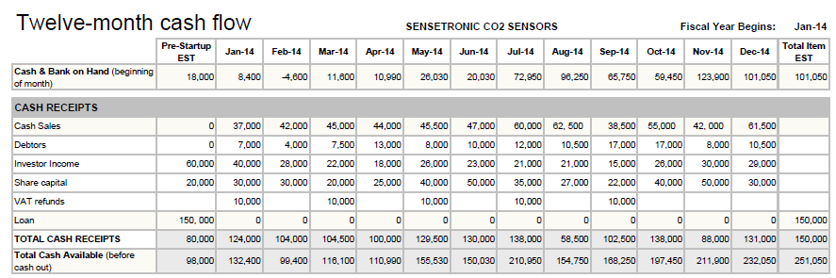
Balance Sheet

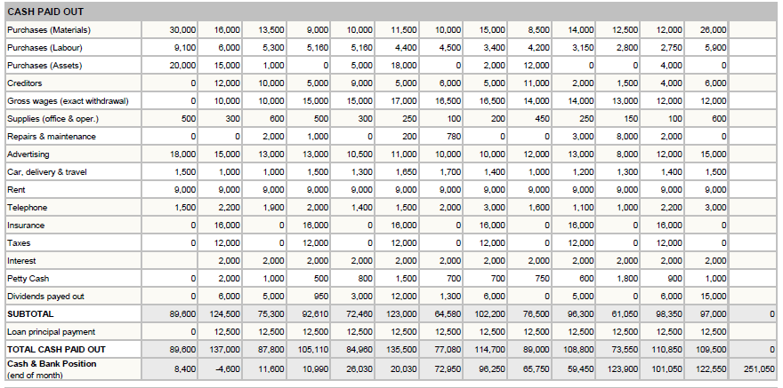

Appendix B

Certificate of Incorporation.

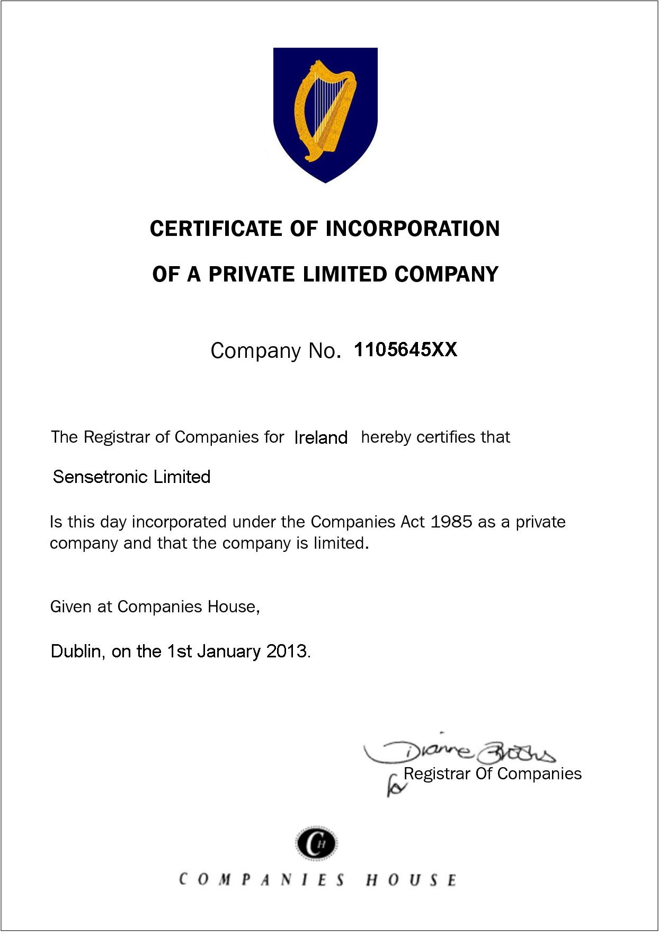

Appendix C


Tax Clearance Certificate



Appendix D

Promoters’ C.V’s.

Ben Callaghan - CEO

PERSONAL SUMMARY
A seasoned and successful leader with a track record of producing, presenting and managing the implementation of innovative business solutions. Highly motivated with a proven ability to develop people and commercialize all aspects of a business. Experienced in converting every opportunity into success and of driving profit and growth. Well networked and highly successful in implementing business process improvements, defining company direction, achieving goals, change and optimising business procedures. Keen to find a challenging position with a successful and ambitious company that offers opportunities for career development and advancement.
AREAS OF EXPERTISE
- Strategic planning
- Financing
- Commercial operations
- Business development
- Feasibility studies
- Project management
- Operational management
- Business finance
- Performance management

PERSONAL DETAILS

T: 01 4684256
M: 087 6232851
E: Ben.Callaghan@sensetronic.ie
DOB: 31/01/1978
Driving license: Yes
Nationality: Irish

PROFESSIONAL
NVQ Facilities Management
MBA

PERSONAL SKILLS
- Strong leadership
- High energy
- Team builder

WORK EXPERIENCE
National Media Company – Dublin
CEO June 2008-Present
Responsible for planning strategic business objectives and also implementing systems and processes to monitor and report on performance against agreed Key Performance Indicators across all the business sectors.
Duties:
- Responsible for driving the growth of revenue and profit margins.
- Responsible for all contracts and lease agreements with key stakeholders & clients.
- Interpreting financial data and drawing conclusions.
- Analyzing operating costs and efficiency.
- Identify skills gaps and devise hiring strategies.
- Winning business from key target clients.
- Implementing systems that reward good staff performance & competence.
- Liaising with key strategic suppliers and customers to define KPI's.
- Reviewing and monitoring all budget expenditure.
- Motivating & providing strong leadership to all departments.
- Developing the company’s commercial processes including account management and marketing.
KEY SKILLS AND COMPETENCIES
- Decisive and forward thinking, with strong vision and strategic capability.
- Ability to network and liaise with clients at every level.
- Experience of Total Facility Management in hard and soft services.
- Experience of operating within highly competitive markets.
- Experience in being instructed by clients at a senior level in major firms.
- Motivational and credible with highly effective interpersonal skills.
- Highly commercial and committed to quality and innovation.
- Operationally strong, financially aware and commercially astute.
ACADEMIC QUALIFICATIONS
BA (Hons)
International Management University 2005-2008
REFERENCES – Available on request.

S.Gormely, Operations Manager

Operations
12 Years manufacturing experience
Production scheduling
Work assignment
Health and Safety Training,
Quality Control,
Resource allocation,
BA (Hons) International management.

Sam Gormley
Operations manager
PERSONAL SUMMARY
Operations manager with experience of successfully coordinating the activities of various departments concerned with the production, pricing, sales, and distribution of products & services. Comfortable working with people of all levels and having a excellent commercial approach to solving problems and developing business processes. Having proven people management skills, with the ability to manage performance and motivate staff on an individual and team level. Now looking for a new and challenging managerial or consultancy position, one which will make best use of my existing skills and experience and also further my personal and professional development.

AREAS OF EXPERTISE
Performance management
Financial control
Customer satisfaction
Recruitment
Staff training
Margin Performance
Commercial awareness
HS&E

PROFESSIONAL
MBA
NEBOSH certificate

PERSONAL SKILLS
- Decisiveness
- Integrity
- Troubleshooting
PERSONAL DETAILS
Sam Gormley

34
Anywhere Road
F
T: 01 888 5544
M: 0877222999
E:s.gormley@sensetronic.ie
DOB: 22/05/1982
Driving license: Yes
Nationality: Irish

WORK EXPERIENCE
Plastics Manufacturing Company – Dublin
OPERATIONS MANAGER
June 2008 – Present
Driving operational improvements, maximizing the value of the asset base while ensuring a tight control on operational costs. Responsible for monitoring and continually improving standards of performance and quality within the operation.
Duties:
- Managing a team of approximately 100 employees in a busy work environment.
- Negotiating contracts, ensuring that they balance value and risk.
- Establish and implement departmental policies, goals, objectives, and procedures.
- Creating, managing and analyzing performance data and other information.
- Ensuring that capacity and capability are continually planned.
- Encouraging, identifying and developing best practice strategy.
- Ensuring compliance to all Environmental Health & Safety goals & objectives.
- Producing Operations manuals which define how the business is to be run.
- Working closely with the Financial Manager, Facilities
- Manager, IT Manager & HR department.
KEY SKILLS AND COMPETENCIES
- Proven ability to lead, motivate and build successful teams.
- Understand all legal, regulatory, information security and compliance requirements.
- Proven influencer & negotiator.
- Achieving targets in a dynamic and complex business environment.
- Team leading & people development skills.
- Able to manage and develop a diverse group of highly skilled people.
- A pragmatic approach to getting the required results.
- Ability to manage operations within budgetary constraints.
- Building and maintaining strong and effective relationships with suppliers and customers.

ACADEMIC QUALIFICATIONS
BA(Hons)Marketing with Management University 2005
-
REFERENCES
–
Available on request.

Ciaran Browne, Company Secretary

Administration and Control.
Manager in
Certified Diploma in Accounting and Finance (ACCA)
BA (Hons) Finance and Business
Dip. In Personnel Management.

FINANCE MANAGER PROFESSIONAL
Somejob Ltd,

53 Some Road
Ashebourne
T: 01888 3545
M: 08722 9459
E: c.browne@sensetronic.ie
DOB: 10/05/1986
Driving license: Yes
Nationality: Irish

Summary
A highly motivated and results driven finance manager who has over three years of invaluable experience in leading and developing a successful finance team. Skilled in numerous financial and accounting fields, including: preparing annual budgets, monitoring key accounts and credit control.
Having the ability to handle complex assignments effectively & possessing the confidence to work as part of a team or independently. Martin is presently looking for a suitable opportunity position with a forward thinking company where he can excel, deliver &achieve his potential.

Skills
Financial
Cash Flow control
Management accounts
Budget preparation
Financial forecasting
Economic awareness
Interpreting financial data
Auditing
Strategic thinking

Career
FINANCE MANAGER
May 2007
-
Present
Accounting Company
Working a busy and high volume environment driving consistency and best practice across all the Businesses. Responsible for improving the company’s cash flow and reducing its arrears by keeping accurate records and ensuring payments are received on time.

- In charge of managing and supporting the ledger team.
- Providing accurate financial information to colleagues and senior managers
- Identifying areas for cost cutting and improvement.
- Ensuring that all financial controls for the division are met and adhered to at all times.
- Giving advice, guidance and support on all financial matter to the company

Academic

BA (Hons) Accounting and Finance

ASSISTANT FINANCE MANAGER
Feb 2006
–
May 2007
Recruitment Company
Management

- Predicting future trends
- Supervisory skills
- Financial regulations
- Decision making
- Managing budgets
- Effective delegation
- Conflict resolution
- Effective delegation
Personal

- Attention to detail
- Communication skills
- Good IT knowledge
- Presentation skills
- Problem solving
- Analytical mind
- High levels of integrity
- Negotiating

References
Available on request.

Brian Murphy, Managing Director

Sales, Marketing.
12 years’ experience in the building safety market
BSc (Hons) Sales & Marketing
Diploma in Environmental Services Engineering.
Self-employed for 8 years.

Managing director
PERSONAL SUMMARY
A results driven, self
-
Motivated and resourceful managing director with a proven ability to develop and strengthen management teams in order to maximize company profitability and efficiency. Experienced leading and growing all sectors of a business to make it a dynamic and progressive organization. Possessing excellent communication skills and able to establish sustainable and profitable relationships with customers, suppliers and stakeholders across the world.
Now looking for a new and challenging managerial position, one which will make best use of my existing skills and experience and also further my personal and professional development.

AREAS OF EXPERTISE
- Project management
- Marketing
- Financial management
- Product launch
- Client retention
- Implementing policies
- Cost control

PROFESSIONAL
MBA

PERSONAL SKILLS
Commercial acumen Innovative ideas
Inspiring innovation
PERSONAL
DETAILS
Brian Murphy

34 Some Road
Tallaght
Dublin 24
T: 01888 5544
M: 08722 9999
E: b.murphy@sensetronic.ie
DOB: 12/09/1985
Driving license: Yes
Nationality: Irish

WORKEXPERIENCE
IT Consultancy Firm–Dublin
MANAGING DIRECTOR
June 2008-
Present
Responsible for the day-to day running of the business with a particular emphasis on
sales and business development. Making sure that the business continues to grow by way of developing new clients whilst maintaining its existing customer base.

Duties:

Identifying,
developing and directing the implementation of business strategy.
Cultivating the company’s reputation in the market & with customers & suppliers
.
Involved in planning & organizing the organization’s activities to achieve targets
.
Responsible for the Profit & Loss responsibility for the business.
In charge of leading, motivating and developing the management team.
Liaising with officials of government departments and regulatory bodies.
Managing multi-disciplined teams and resolving any conflicting priorities.
Developing business plans and preparing comprehensive business reports.
Improving margins and maintaining a high quality service to clients.
Reviewing, refining and developing the strategy and direction of the company.
Building client relationships that result in revenue and profitability growth.
Responsible for the companies health and safety and legislative adherence.
Creating and maintaining links with other trade and professional associations.
Keeping control of business expenditure, ensuring it's within agreed budgets.

KEY SKILLS AND COMPETENCIES
Strong leaderships skills in board governance, new business development.
Comprehensive understanding of financial management principles.
Entrepreneurial with commercial acumen and excellent management skills.
A motivated team player who is results driven.
Results-oriented with a positive outlook, and a clear focus on high quality and business profit.

ACADEMIC QUALIFICATIONS
BA (Hons)Management University 2005
-
REFERENCES
–
Available on request.

Appendix E
Equipment Schedule.

Appendix F
Typical Product Drawings

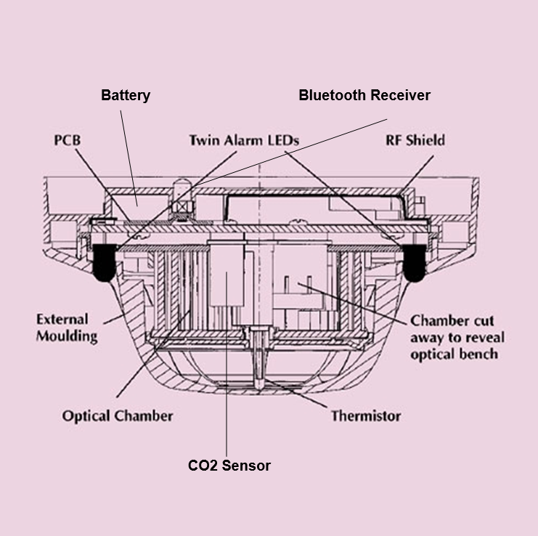

References

Safe Lincs. (2013). Sensor.
Available: http://www.safelincs.co.uk/apollo-xp95-multisensor-detector.
Last accessed 20 Oct 2013.

Futurlec. (2013). Sensors.
Available: http://www.futurlec.com/Gas_Sensors.shtml.
Last accessed 20 Oct 2013.

Co2. (2013). Co2 Meter.
Available: http://www.co2meter.com/.
Last accessed 20 Oct 2013.

Day Job. (2013). CV's.
Available: http://www.dayjob.com/content/management-cv-template-271.htm.
Last accessed 24th Oct 2013.

Safety Ireland. (2013). Tax Clearance.
Available: http://www.safetyireland.com/pdf/tax_clearance_certificate.pdf.
Last accessed 24th Oct 2013.

